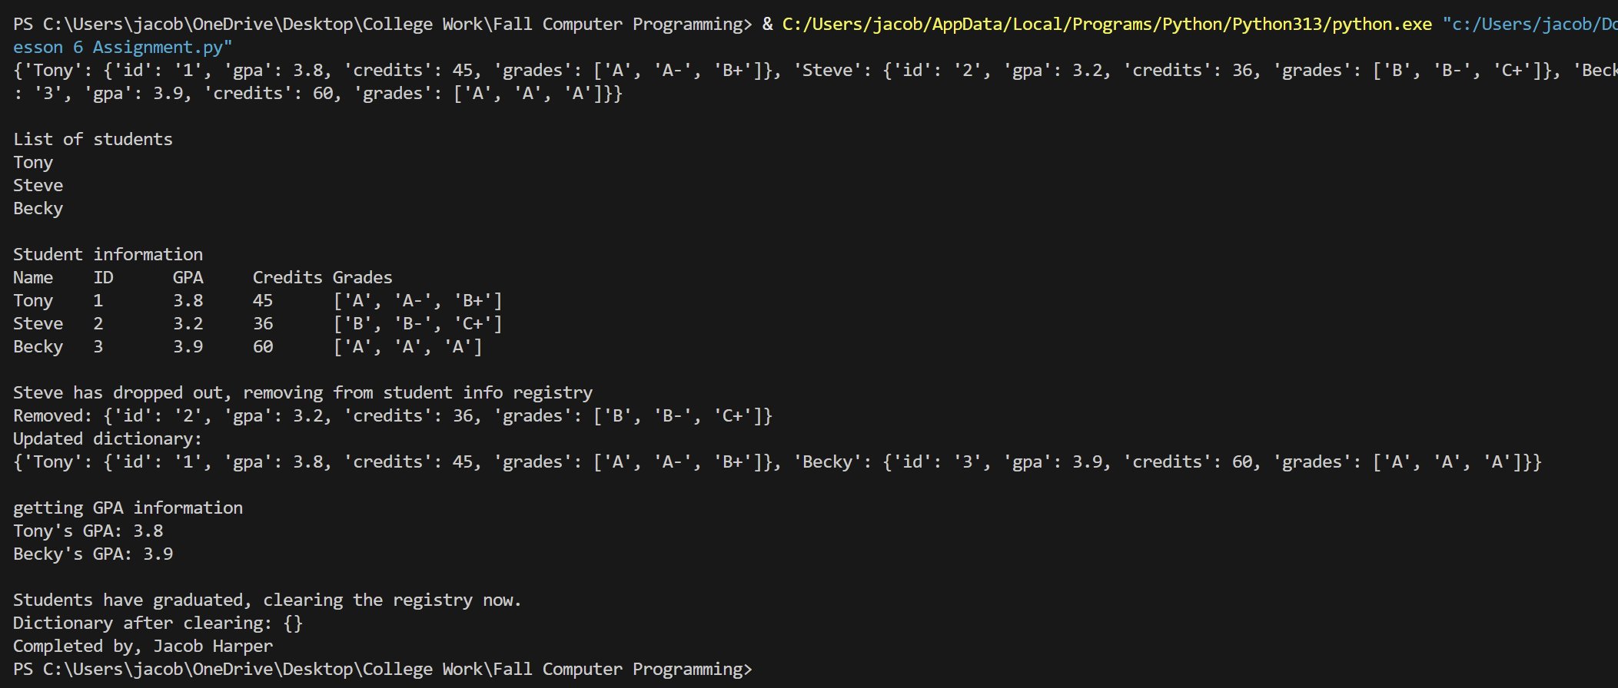def main():

students = {}

students["Tony"] = {
"id": "1",
"gpa": 3.8,
"credits": 45,
"grades": ["A", "A-", "B+"]
}

students["Steve"] = {
"id": "2",
"gpa": 3.2,
"credits": 36,
"grades": ["B", "B-", "C+"]
}

students["Becky"] = {
"id": "3",
"gpa": 3.9,
"credits": 60,
"grades": ["A", "A", "A"]
}

print(students)
print()

print("List of students")
for name in students:
print(name)
print()

print("Student information")
print("Name\tID\tGPA\tCredits\tGrades")

for name, info in students.items():
print(name + "\t" +
info["id"] + "\t" +
str(info["gpa"]) + "\t" +
str(info["credits"]) + "\t" +
str(info["grades"]))
print()

print("Steve has dropped out, removing from student info registry")
removed_student = students.pop("Steve")
print("Removed:", removed_student)
print("Updated dictionary:")
print(students)
print()

print("getting GPA information")

for name in students:
gpa = students.get(name).get("gpa")
print(name + "'s GPA:", gpa)
print()

print("Students have graduated, clearing the registry now.")
students.clear()
print("Dictionary after clearing:", students)

if __name__ == "__main__":
main()
print("Completed by, Jacob Harper")

